Dinner Menu Friday 20th January 2023
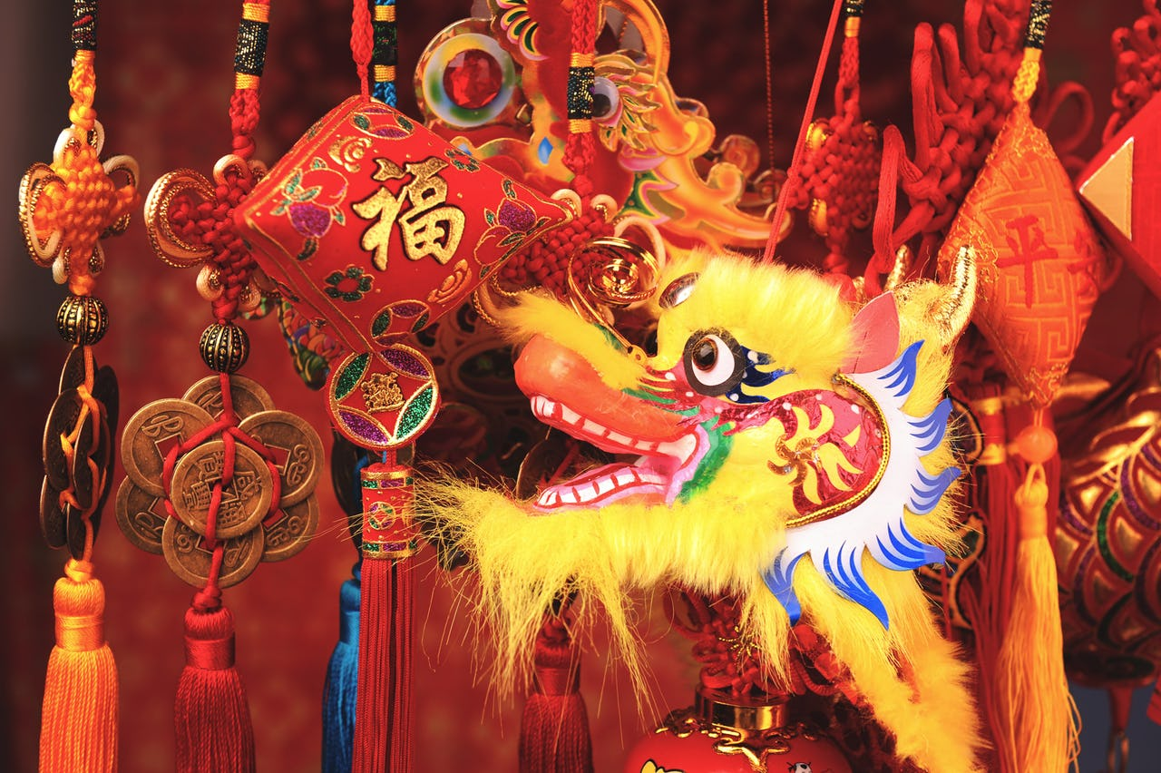

Time to celebrate the Chinese New Year
Year of the rabbit

Chicken Fried Rice
Chips
Curry sauce
Stir Fry Vegetables

Rabbit Shaped Shortbread
Orange Pieces – for good luck
Milkshake / Milk / Water

